- 2nd Iteration: Informal Chat with Sixth Form Stakeholders

  - I conducted an informal chat to show the first game layout design to my Sixth Form Stakeholders and they suggested that the variables above the game would be better dispersed along the horizontal line at the bottom of the game rather than being shown in a vertical list. They also suggested that I add the username and their avatar next to the game title. Based on this feedback, I created the second iteration of the game layout as follows.

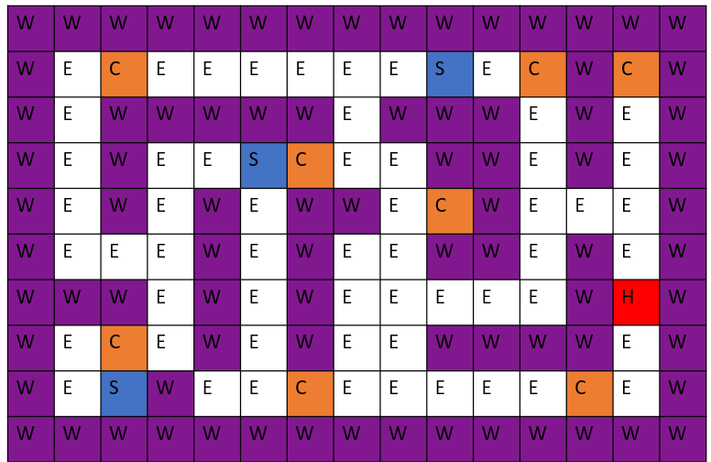
Score: Lives: Time Taken:
Game Stats as it is played updated in real time.
Include Accuracy?
Include MaxTime?
Cyber Maze
Name of Maze selected and username + avatar (personalises it.)

The Maze game itself
Alternative Layout
When the game completes, display “game over” and give the option whether to record the performance or not
GiraffeLeaf

- 2nd Iteration: Design Survey of Sixth Form Stakeholders

  - With two designs of game layout to consider, I ran a formal survey of my Sixth Form Stakeholders. I restricted this phase of stakeholder feedback to the Sixth Formers because they are the only stakeholders who will be playing the game initially and I am keen that the layout appeals to them.

  - Most of the stakeholders (80%) preferred the second design, which had been developed to take into account their informal feedback.

  - This was the survey that I used:

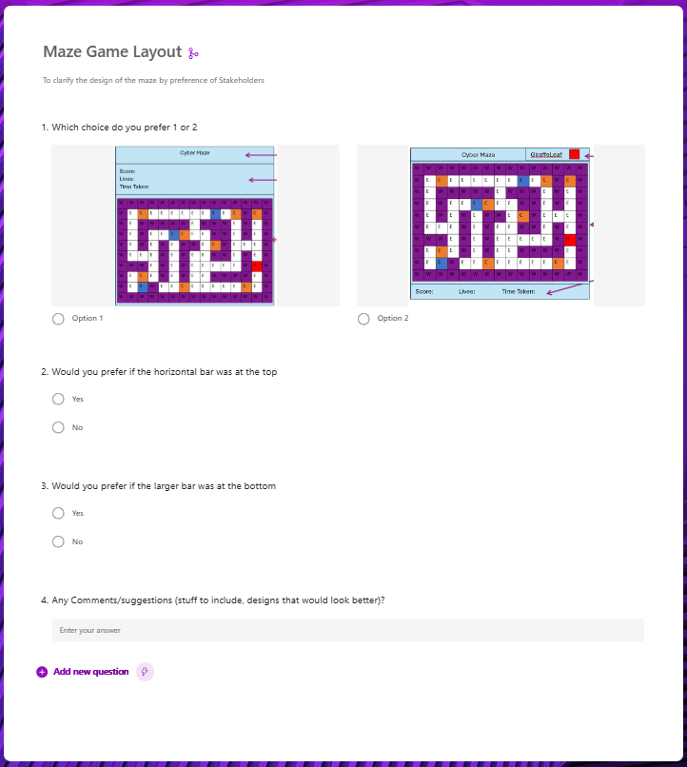
  - This is a summary of their responses:
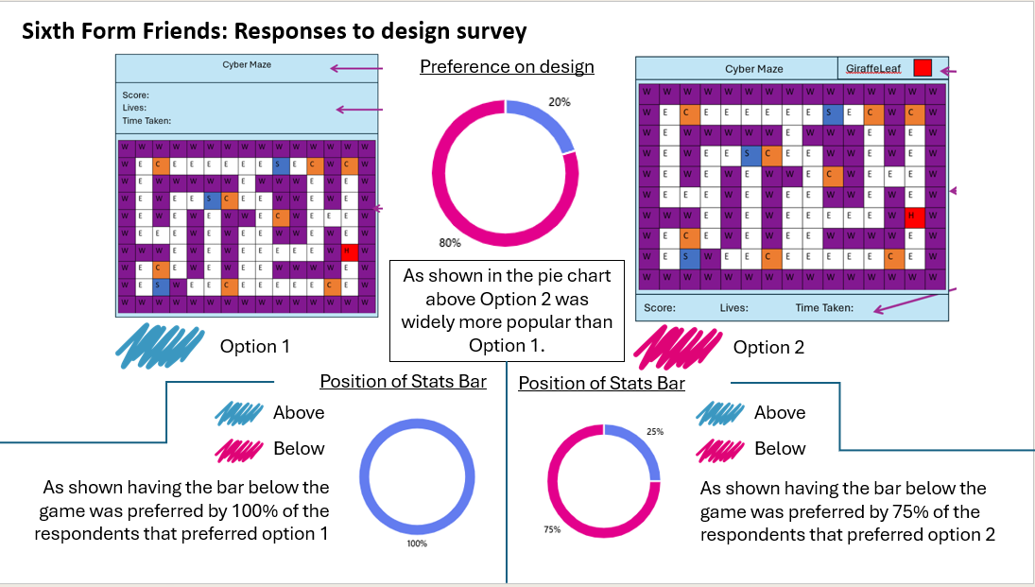
  - I also received the following comments on some additional points to consider:
“I would love if the Avatar icon was nearer the centre of the top bar”
“more evenly space the bottom stats”
“A Retro Game look (use of greens and blacks)”
“nahhhhhhh it’s all swagggg”
- 2nd Iteration: Design Response to Stakeholder Feedback
  - Following the stakeholder feedback, I created a final design to accommodate the majority feedback.
Score:__ Lives:_ Time Taken:__:__:__
Game Stats as its played updated in real time.
Include Accuracy?
Include MaxTime?
Cyber Maze
Name of Maze selected and username + avatar (personalises it.)

The Maze game itself
GiraffeLeaf

